Tempero Ludum Journal Template

The game is called Busy Bee. I honestly was hitting a wall with ideas and I looked outside and saw a honey bee in my garden. I really enjoy bees and think they are fascinating, and I wanted to try and create a co-op game, so I went with that idea.

Week 1

Brainstorm Ideas
MECHANICS:
1. Roll dice to determine starting player
2. Move pieces around board
3. Work together to achieve goal (Change this for simplicity sake)
4. Save a die roll for later use
5. Defeat enemies
6. Help other player
7. Beat game in a set number of rounds
8. Choose a character
9. Re-roll a dice
10. Unlock a locked dice
PLAYER CHOICES:
1. Players choose a starting character
2. Players choose which direction to move in on game board
3. Players choose which action to take on their turn
4. Players choose two starting abilities to use during gameplay
5. Players can choose to either sneak or knockout enemies

Week 1 Play test

What went well -
I did my first playtest alone, and overall I think the game is fun. It is enjoyable, and I think if it were played with another human, then the co-op element would be more present. The game doesn’t take a long time to play, I clocked in at 15 mins and 26 secs. I feel as if the mechanics do work together well.

W1T1 What needs to change
My game board definitely needs some modifications, I felt as if it made movement too easy and while it did offer the players freedom it also hindered any sort of strategy or challenge. I also think I need to take away some flower spaces. In my head it made sense to do 10 flower spaces for 10 tokens, but it also takes away from the challenge. Apropo to that, I need to work on utilizing my blocked spaces, while playing I was able to avoid them every single time. And at the end of the game, I found myself having one pawn who had collected all the tokens and returned them to the hive and then another pawn who needed one more...meaning I just had to keep rolling as one player. I would like to add another element to the game win conditions to prevent this.

W1T1 Play Test Image
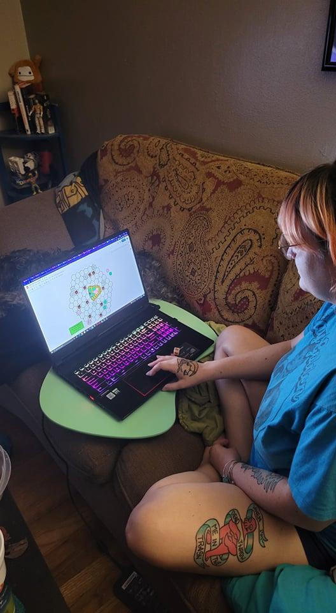

Week 2
When I first created my spreadsheet, I tracked: dice rolls, how many “special” spaces were landed on, how many rounds a game took, and how many times a player’s dice were locked. However, after my first playtest, I realized I needed to also track the movement of the tokens (ie: when a token was placed, picked up, or placed into the hive).

Perform playtests
Print out your rules and board (you may also use roll20.com as described in lecture). Be sure you have 2 dice and any other pawns needed.
Find two players and have them read your rules. Do not explain the rules, but simply have your testers read the rules. No really. DON’T ANSWER QUESTIONS. Remote players will be downloading your game soon, so you won’t be there to answer questions.
When you see testers get confused about rules, take this down as a note and change the instructions after the test.
Use your tracking spreadsheet to track events in the game. Since your game is unique to you, I can't tell you which events need to be tracked. It will be up to you to decide what you track and how you do it.
When the testers finish a game, ask them about what can be improved and what should stay the same. Take down these notes as well.
After the test, revise your game. The assignment guidelines for the Tempero Ludum remain the same as week one, but you can revise your rules within the same constraints.

Week 2 Play tests

W2 Test #1 What went well -
The game flows smoothly. Rules were very clear and concise, there were only a few things players were confused on (could they move diagonally etc). Players seemed to work well together.

W2 Test #1 What needs to change -
Honestly, the game is kinda boring. I could tell players were starting to get disinterested the longer the game dragged on. Plus, whenever a player has finished their objective they are left with nothing to do. I need to add a function to resolve this issue. Snake spaces were absolutely no challenge as well.

W2T1 Play Test Image
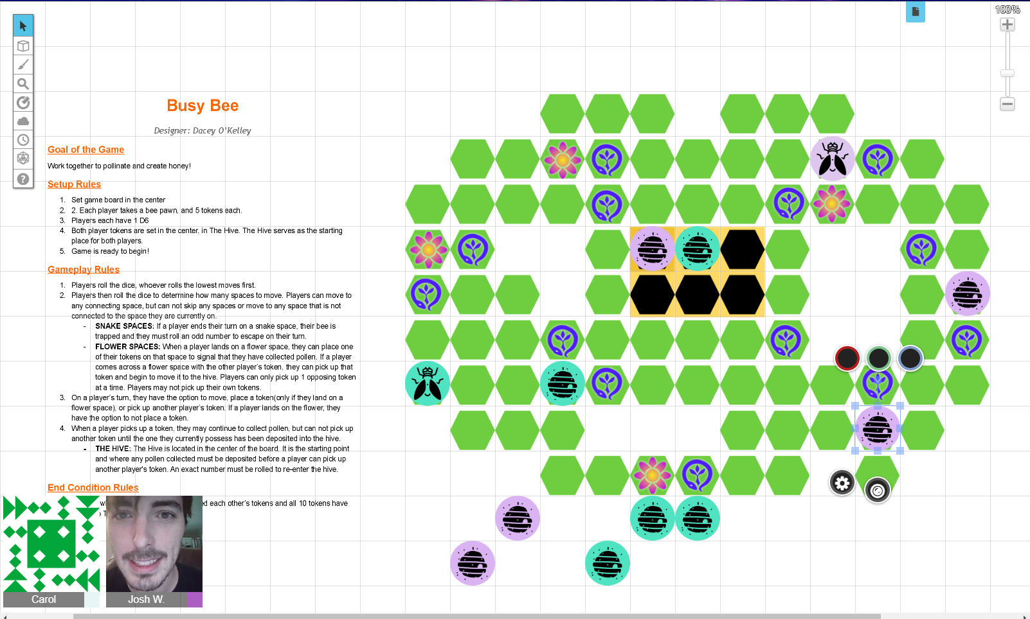

W2T1 Play test tracker
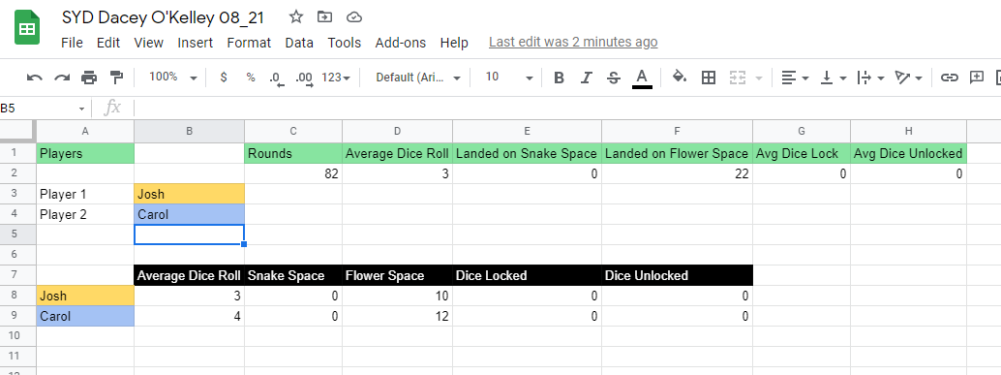

W2 Test #2 What went well -
I wanted to create a co-op game that promoted communication and strategy and I did that! Both players were talking about their moves and really trying to get the job done within the round limit. Rules were clear and there was not a lot of confusion.

W2 Test #2 What needs to change -
After the previous playtest, it was suggested to add diagonal movement, so I did. While both players in this playtest liked it, they did say it broke the game and was too OP. I also added the round limit in this playtest, to which the players enjoyed but said was too short...so it has been upped a bit. While tracking the data, the average rounds it takes to complete the game is around 20..but I wanted to go with something that was challenging so I have changed it to 15 rounds. Given the round limit addition, I need to add a way for players to track the round they are on. I also noticed that players were...getting creative with their moves. Instead of landing on the flower space, they were making their moves more strategic and passing through the flower spaces, picking up and then plotting the rest of their moves. I allowed this as I honestly just wanted to see if it would break the game. I actually kinda liked it and felt as if it added a layer of strategy to their moves, while also balancing the challenge of a round limit. Both players recommended either adding more snake spaces or editing their functionality...which I will be doing in the next iteration. Also, adding the element of if a player has deposited all pollen and has no tokens left to place on board, then they can use their rolls to help out the other player.

W2 T2 Play Test Image
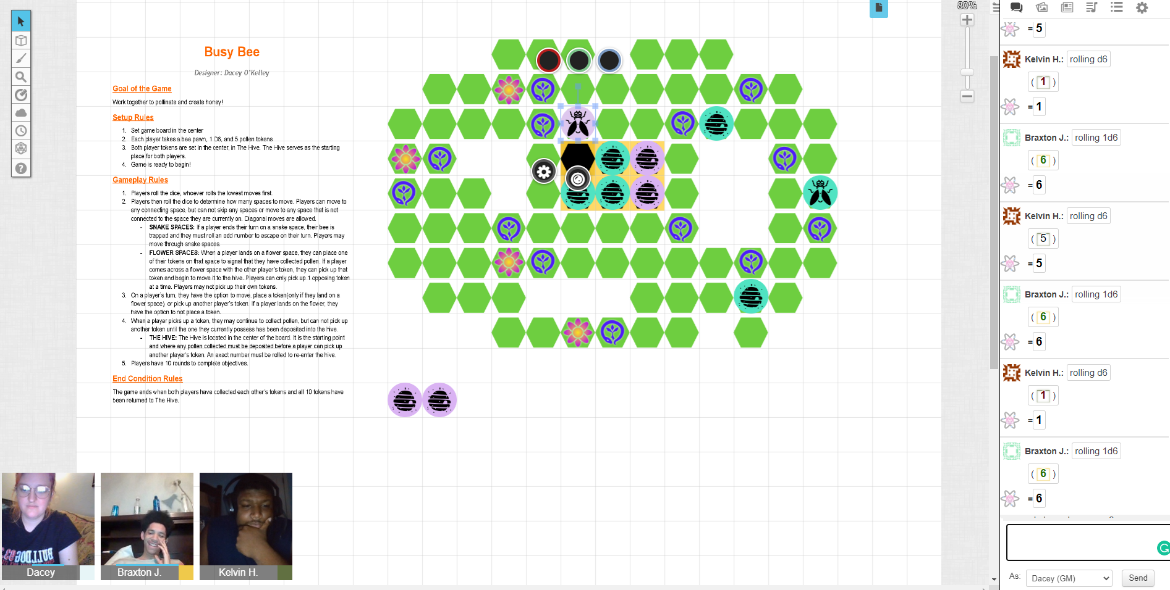

W2 T2 Play test tracker
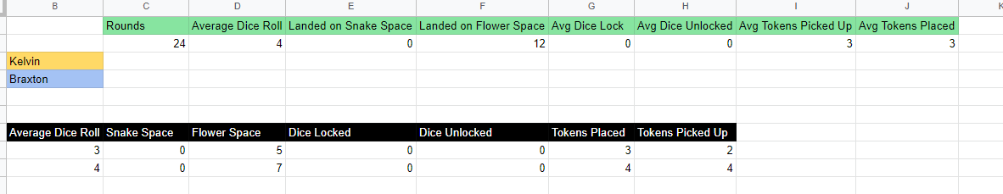

W2 Change List

- Added round limits
- Added functionality to snake spaces, hopefully making them an actual challenge
- Added element of giving “finished” player the ability to help other player
- Removed diagonal movement
- Testing out different forms of allowed player actions/movement.

Week 3

Week 3 Play tests

W3 Test #1 What went well -
This is probably the first playtest where I felt as if the game was near completion! Observing the gameplay, it flowed really well and the players did a good job of getting into the game and communicating with each other.

W3 Test #1 What needs to change -
I am upping the round limit to 20, 15 is just not enough. Rearranging the snake spaces so they are more balanced. There was also some stuff in my rules that I had forgotten to take out and reword.

W3T1 Play Test Image
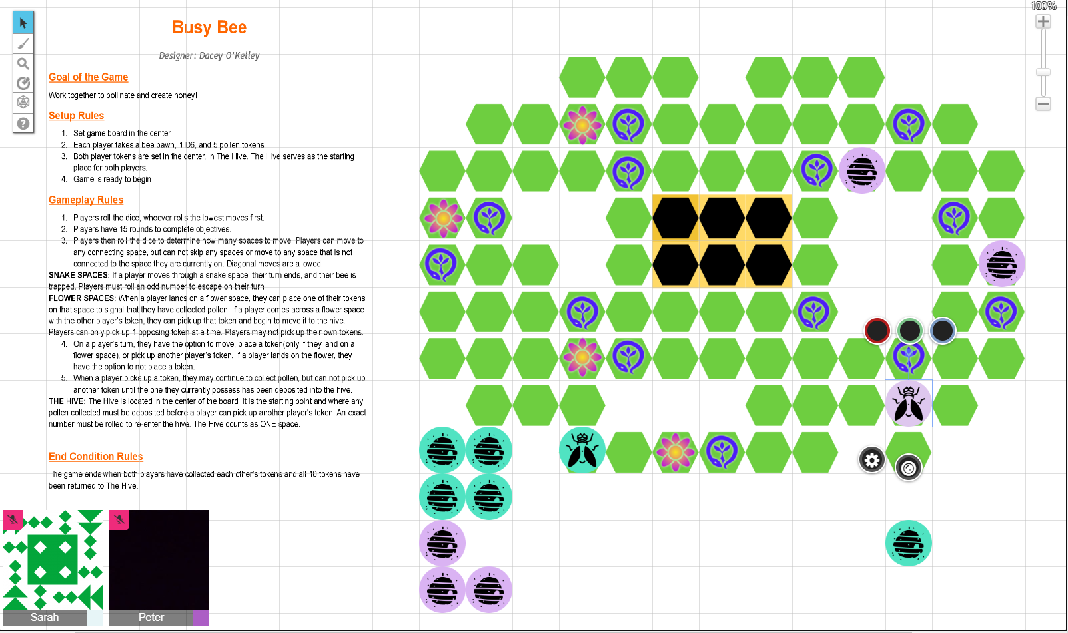

W3T1 Play test tracker
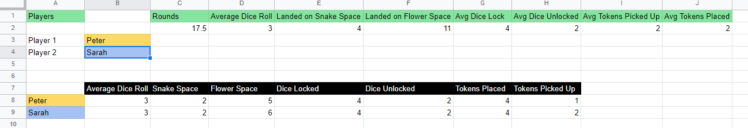

W3T1 Test #2 What went well -
The game felt pretty finished while watching it. Players were engaged, and I enjoyed that they were using the snake spaces to their advantage instead of just avoiding them entirely.

W3T2 Test #2 What needs to change -
Even with adding the extra five moves to the round limit, players weren’t able to finish the game. Suggestions included either reducing the number of tokens or adding more flowers. I also noticed that players tend to naturally move in opposite directions starting out, meaning they are dropping their tokens on one side and then having to move to the other side to pick up. I’m honestly not sure how to absolve this issue, as I do not want to take away from any strategies.

W3T2 Play Test Image
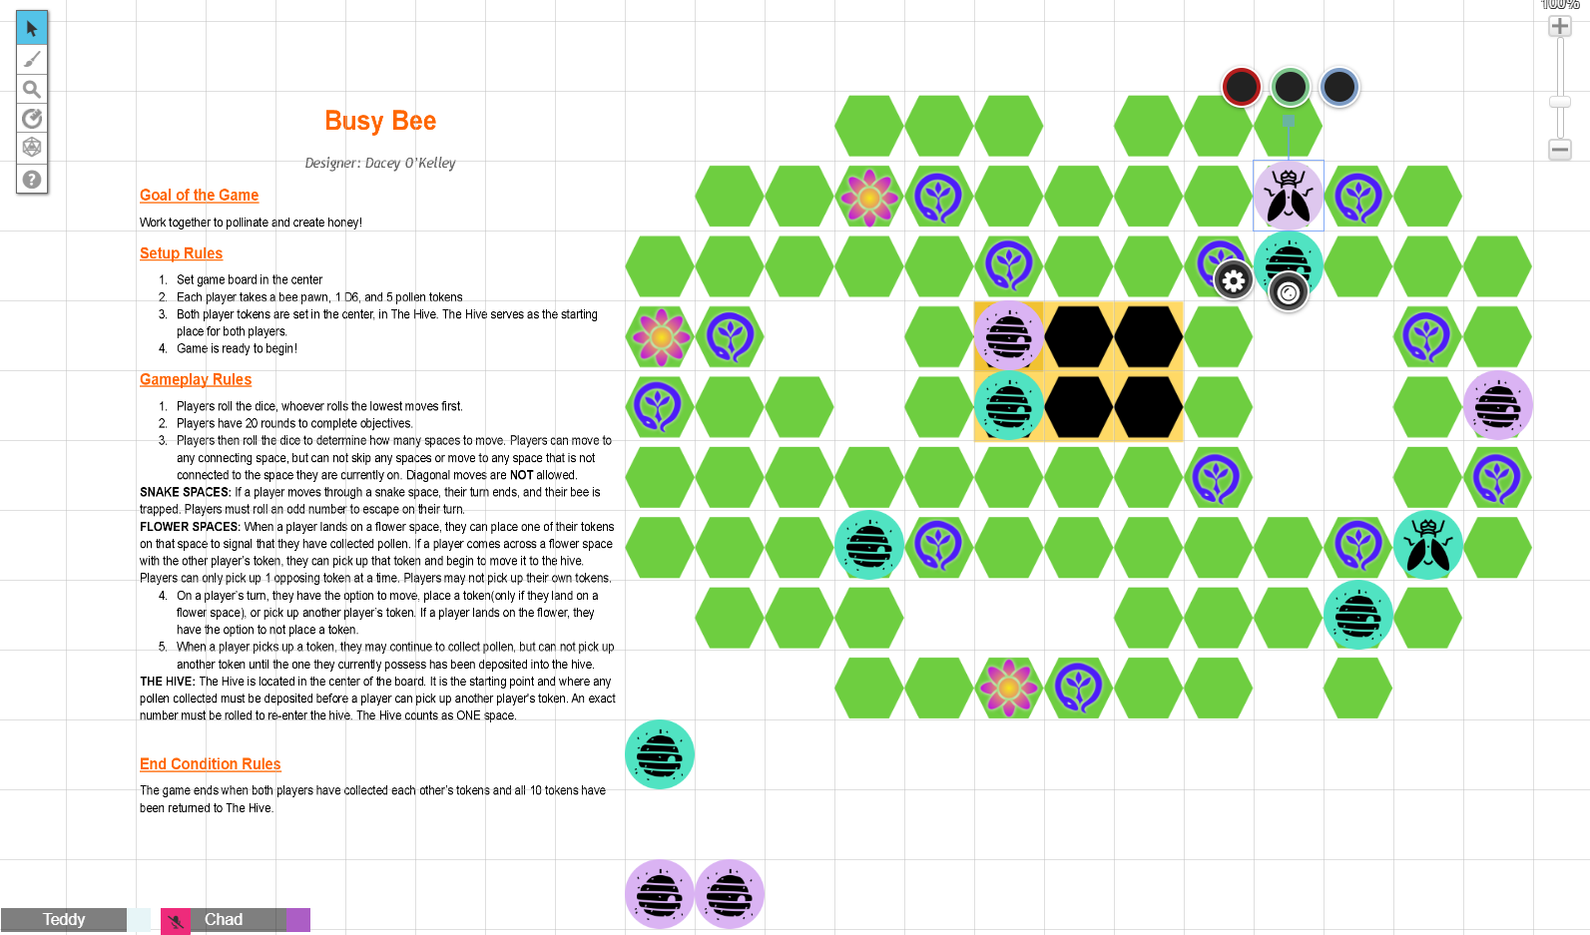

W3T2 Play test tracker
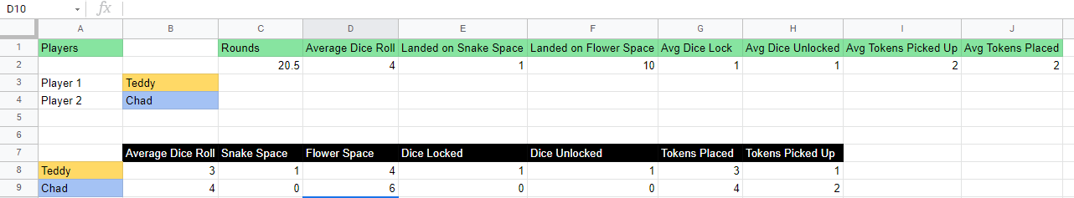

W3 Calculate probability
Go through your current version of the game and look at all the places you roll dice. Pick at least 2 different events and calculate the probability of each outcome for that event. For example, in Ur, we can calculate the probability of moving 0,1,2,3, or 4 spaces on each roll.

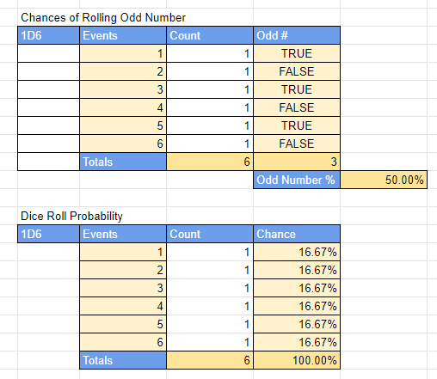

Add more test note logs as needed. 2 tests are minimum, but more are highly recommended.
After this section is filled out, export this document as a pdf file (from the”File->Download” menu up top in the toolbar)

W3 Change List
You are required to address at least one piece of feedback from a peer and make AT LEAST 2 additional major revisions to the game each week. They should be listed below

Copy / paste the “improve” section of feedback from your discussion post here, then write about how you addressed it. Delete this text when you are done.

- Revision of rules to use concise language
- Rearrange snake spaces so they are more balanced
- Upped round limit based on player feedback and data tracking.
- Added 2 more flower spaces

Week 4
For this week, try and get all the final polish on your month-long project. If you can, make the board look nice. Make sure all the directions are clear and free of grammatical errors. Do a final pass (I know, it's a lot of iteration, but that's what we do).

Week 4 Play tests

Final Play Test
I really enjoyed doing the experiments, because it didn’t feel as “final” as a change to the game. It was nice to do several different playtests that each yielded different results. This whole assignment I have been struggling with what to do with the snake spaces and how to make them useful/an actual challenge. I did a playtest without them, and it was by far my best playtest. The players had a lot of fun! It was still stressful with the round limits, and I was worried about the game being too easy without the snake spaces. However, it turns out the game works best without them. I also ran a test with double the snakes and the game was just impossible and hard to watch.

Play Test Image
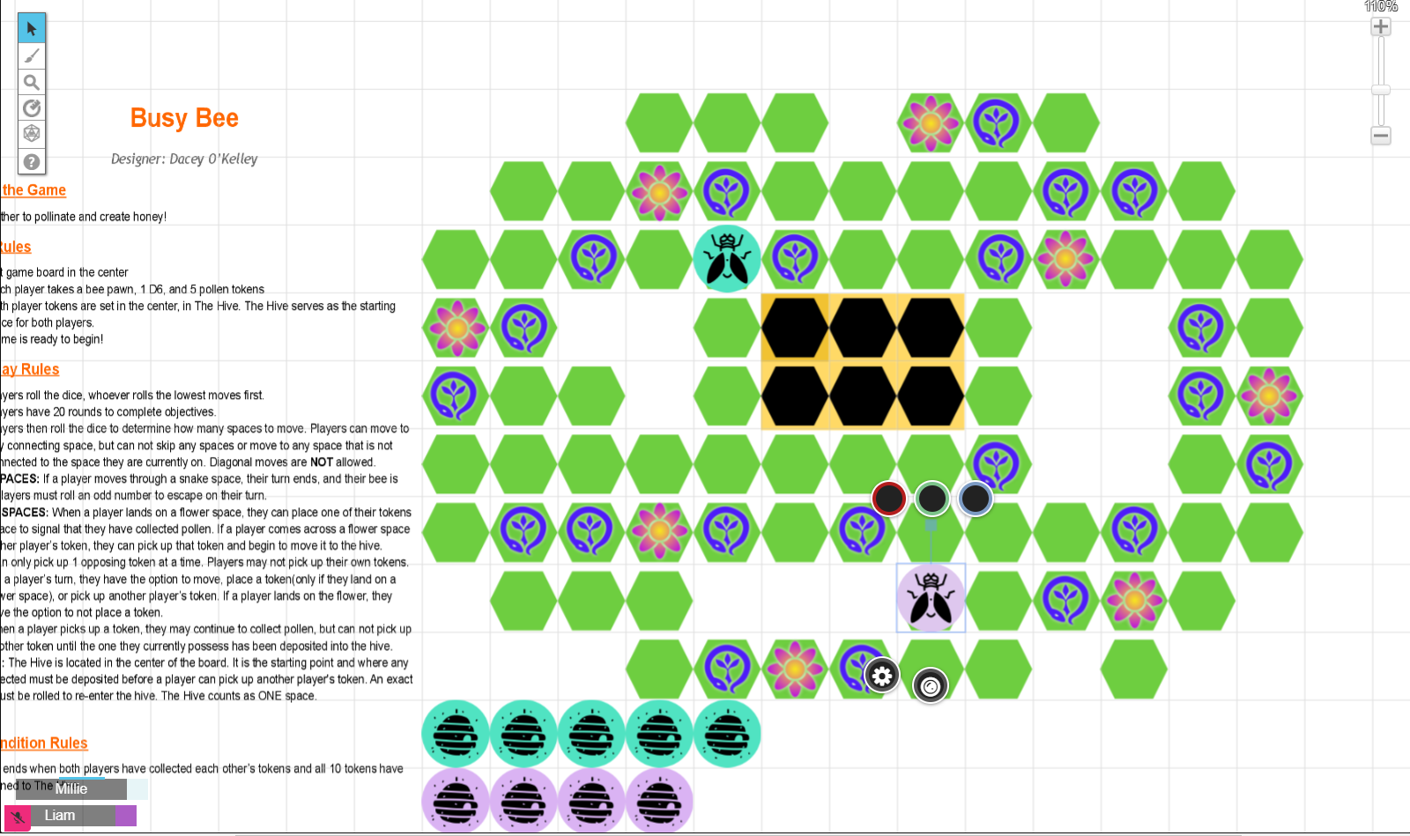
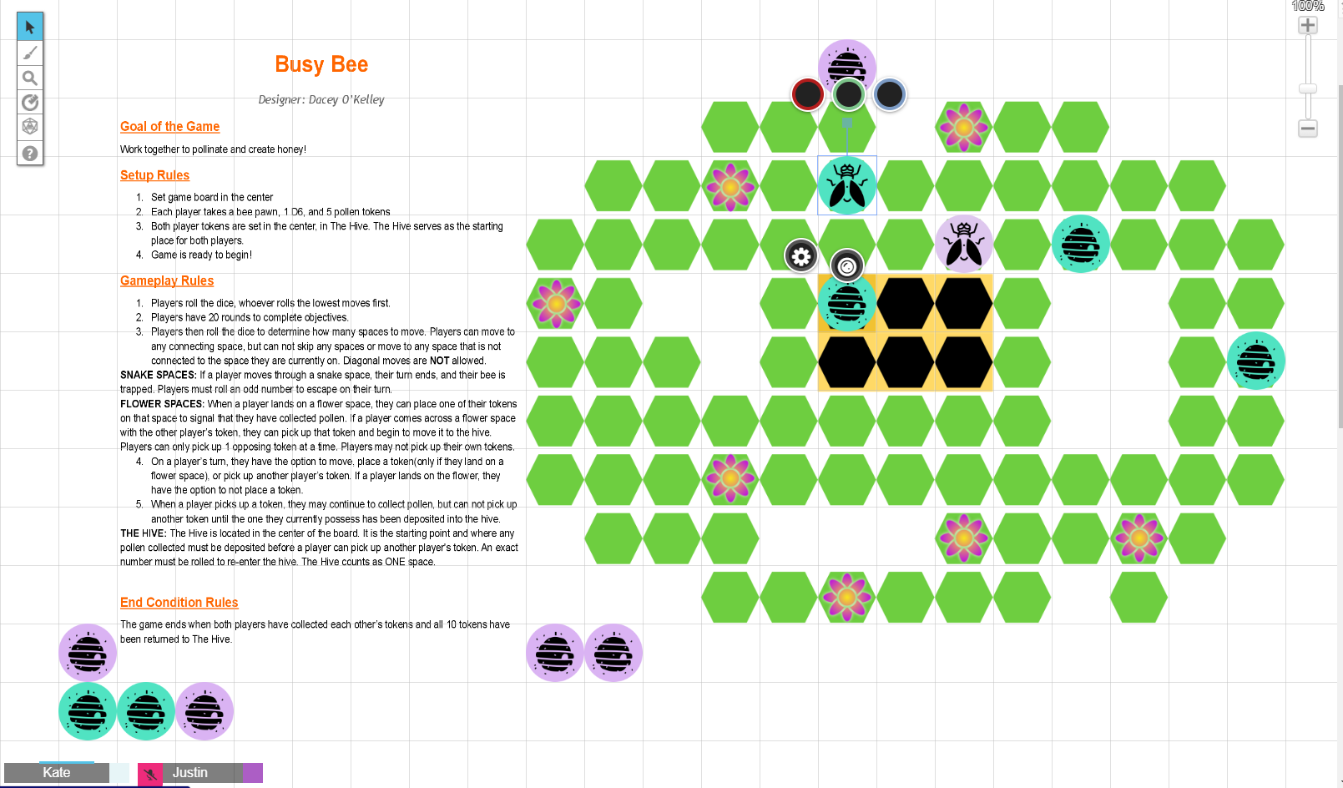

Experiments
Three Changes:
1. Double the snake spaces:
- Game was almost unplayable. My players did not have fun AT ALL. It was hard to watch it being played honestly. It was just bad, I feel like there’s not much else to say other than it absolutely did not work.
2. Completely removed snake spaces:
- BY FAR THE BEST! My players had so much fun! They were working together and the round limit still gave that pressure I wanted. It was funny because at first they decided on a strategy, and then one player just didn’t follow it...so they didn’t get to the finish the first time. But then they actually wanted to play again and stayed true to their strategy and finished within the limits! I had been afraid of removing the snake spaces, but I’m really happy that I did this experiment.
3. Reduced number of tokens:
- I thought maybe reducing the tokens would help players achieve the goal easier. I started with 3 tokens, and the game was just boring. It was too easy and one player went ahead and dropped tokens and was left with nothing to do while the other player worked on getting something on the board. I then bumped it up to four tokens, and it was a little better. However, the general consensus was that it still made the game too easy. NOTE: This test was done with the removal of the snake spaces, as that is a change I ended up keeping.

Change List
You are required to make AT LEAST 3 major revisions to the game each week. They should be listed below. For this final week, your changes may be your experiments, or last changes needed to improve the game. Also include your feedback comment and how you addressed it.

- Removed snake spaces entirely.
- Rules revision to reflect board changes.
- Revised rules to clarify some things that were not clear.

Final Thoughts
Part of the reason I really enjoy game design is because I genuinely enjoy clerical work. I loved getting to see the data and analytics of my game and make changes with those in mind. At the beginning, I really didn’t like my game. I felt as if it was too weak/childish, but after the many iterations and playtests I am happy with the final result! I liked that we posted our games each week to the discussion boards and had our peers give us feedback. People in our program understand what to look for, and are a bit more critical. I also felt more comfortable with asking people to playtest and sharing my game with strangers, something I struggled with early in the program.
Overall, I feel more confident in my ability to playtest and track data and raise my baby game to be a well-adjusted teen. Looking forward to continuing to learn and refine the skills I have learned.

